Life cycle of a Star

http://www.telescope.org/pparc/res8.html
NEBULA. A nebula is a __________ of gas and dust in space. Nebulae are the __________ of stars.
STAR Main Sequence. A star is a _______ globe of gas producing its own heat and light by nuclear fusion.
Luminous= giving out light.
RED GIANT. This is a large bright star with a cool surface. It is formed during the ___________ stages of the life of a star like the Sun, as it runs out of __________ fuel at its centre.
SUPERNOVA . This is the _________ death of a star, and often results in the star obtaining the brightness of 100 million suns for a short time.
NEUTRON STARS. These are produced when a super __________ explodes., Neutron stars are very ___________. Typical stars having a mass of three times the Sun but a diameter of only 20 km. If its mass is any greater, its gravity will be so strong that it will shrink further to become a black ______________
. BLACK HOLES. Black holes are believed to form from massive stars at the end of their lifetimes. The gravitational pull in a black hole is so great that ___________ can escape from it, not even _________. Holes distort the space around them, and can often suck neighbouring matter into them including _____________.

Nebula Names
Nebulae get their names for a number of reasons. Some nebulae get their name from what they look like. Some nebula are named after famous people. Some nebulae are just given numbers.
Some Famous Nebulae. Find information for these nebulae using the internet.
Name of Nebula | When was it discovered? | How far from Earth in Light years(Ly) | Colours you can see in the picture of the nebula
Cat’s eye
Dumbbell
Lemon slice
Hour glass
Keyhole nebula(Carina)

What was used to give these nebulae their name?
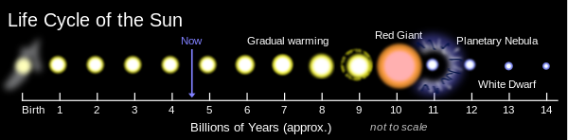

Look at this diagram above. It is timeline for our sun.
How long from now will our sun last before it becomes a red giant?

How old is our sun at the moment?

Which bit of the lifecycle has not been shown here?

